Peer Reviewed and Open Access in Alma | 

Yoel Kortick
Senior Librarian

See also: Search Results Icons.

Peer Reviewed
As referenced in Peer Reviewed - Search Field Descriptions - Additional Information for Advanced Search records with the text Refereed/Peer-reviewed in the 500 field subfield a will

- Have an indication in the repository search results that they are “Peer Reviewed”
- Be retrievable via advanced search “Peer Reviewed = Yes”

For example, see this search and the repository search results:

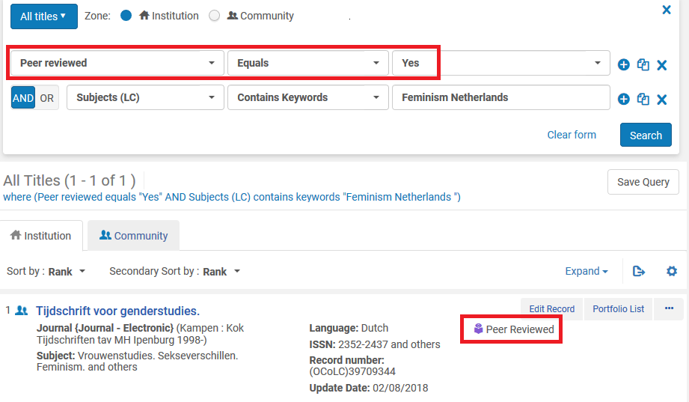

The reason the above occurs is because of this is in the record:

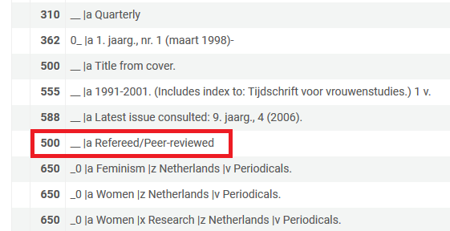

Open Access
As referenced in Open Access - Search Field Descriptions - Additional Information for Advanced Search records with the text Unrestricted online access in the 506 field with first indicator 0 subfield f and text star (star is Standardized terminology for access restriction) in 506 field with first indicator 0 subfield 2 will

- Have an indication in the repository search results that they are “Open Access”
- Be retrievable via advanced search “Open Access = Yes”

This uses the standard 506 subfield f definition as it appears here: http://www.loc.gov/marc/bibliographic/bd506.html

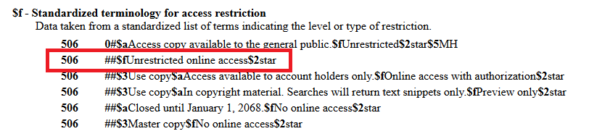

For example, see this search and the repository search results:

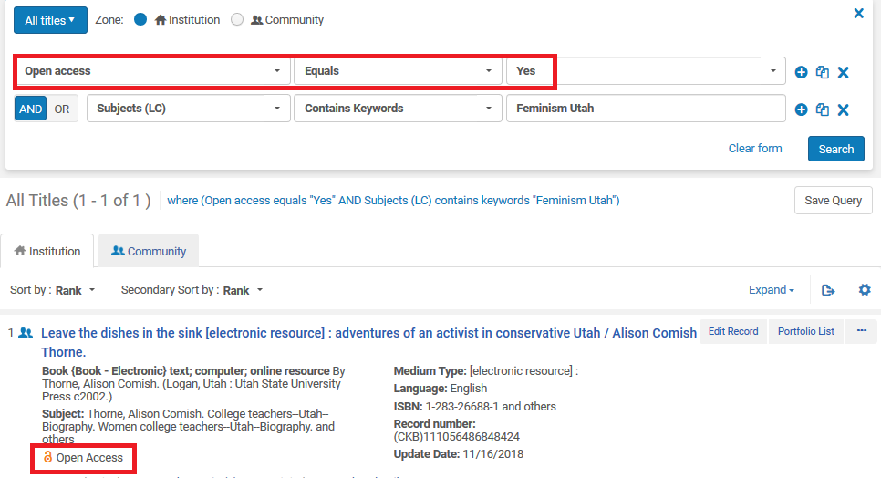

The reason the above occurs is because of this is in the record:

